
COMSATS University Islamabad (CUI)

Project Proposal

LatentGuard
Adaptive Dual Layer WAF for Anomaly and Threat Detection

Version 1.0
By
Syed Shaheer Khalid CIIT/SP23-BCT-048/ISB
Javaria Maqbool CIIT/SP23-BCT-023/ISB

Supervisor
Ma’am Farhana Jabeen

Bachelor of Science in Computer Science (2023-2027)

Table of Contents
Abstract: 1
1. Introduction 2
2. Problem Statement 3
3. Problem Solution/Objectives of the Proposed System 3
3.1 Proposed System 3
3.2 Objectives 4
4. Literature Review /related Systems: 4
5. Vision Statement 5
6. Scope 5
7. Modules 6
7.1 Reverse Proxy Traffic Interception 6
7.2 Traffic Normalization and Feature Extraction 6
7.3 Rule-Based Filtering Engine 6
7.4 AI-Based Anomaly Detection (Autoencoder) 6
7.5 Latent-Space Clustering Validation (HDBSCAN) 7
7.6 Multi-Signal Consensus Decision Engine 7
7.7 Logging, Explainability, and Data Storage 7
7.8 Attack Pattern Mining Engine 7
7.9 LLM-Assisted Rule Generation 7
7.10 Human-in-the-Loop Rule Validation 8
7.11 Continuous Learning and Model Fine-Tuning Loop 8
8. System Limitations / Constraints 8
9. Data Gathering Approach 9
10. Project Contribution 9
11. Relevance to Course Modules: 10
12. Tools and Technologies for Proposed Project 10
13. Project Stakeholders and Roles 11
14. Module based Work Division 12
15. WBS and Gantt Chart 13
16. Mockups 13
17. References 15
18. Plagiarism Report 15

Project Category: (Select all the major domains of proposed project)
A-Desktop Application/Information System B-Web Application/Web Application based Information System C-Problem Solving and Artificial Intelligence D-Simulation and Modeling E-Smartphone Application
F-Smartphone Game G-Networks H-Image Processing
Other (specify category) ________________

Abstract:
The rapid evolution of sophisticated cyber threats, including zero-day exploits and evasion techniques, necessitates the development of more adaptive and intelligent web application firewalls (WAFs) to safeguard modern web applications effectively. Existing traditional WAFs primarily rely on signature-based detection using static rule sets, such as the OWASP Core Rule Set, which excel at blocking known attacks like SQL injection and XSS but suffer from high false positive rates that disrupt legitimate user traffic and operational efficiency. Moreover, these systems struggle significantly against novel, zero-day vulnerabilities and polymorphic attacks, as they cannot detect threats without pre-existing signatures, often leading to missed detections or requiring constant manual tuning. The proposed project addresses the critical gap in current solutions by introducing a hybrid, self-learning WAF that has robust integration of unsupervised deep learning for zero-day anomaly detection with automated, AI-assisted rule generation to minimize manual intervention and false positives. The primary objectives are to design a dual-layered architecture featuring AI-generated dynamic rules for pre-filtering, a deep fully connected autoencoder trained on benign traffic for accurate anomaly scoring via reconstruction error, HDBSCAN-based density clustering to distinguish rare legitimate behavior from true outliers, and a conservative consensus-based decision engine with full explainability; furthermore, to establish a closed-loop self-learning mechanism leveraging large language models (LLMs) to automatically generate and deploy new ModSecurity-compatible rules from confirmed attack patterns after human review. This project will deliver a next-generation WAF product that achieves significantly higher detection rates for both known and emerging threats, dramatically reduces false positives through multi-model agreement, provides strong auditability for security teams, and continuously adapts to evolving attack landscapes with minimal human effort, ultimately enhancing overall web application security posture while maintaining high performance and usability.

Introduction
This project outlines the development of an enhanced, AI-augmented Web Application Firewall (WAF) designed to provide adaptive, low-false-positive protection against both known and emerging cyber threats targeting modern web applications.
Web applications continue to be prime targets for attackers, facing a rising tide of sophisticated attacks, including but not limited zero-day exploits, AI-generated polymorphic payloads, and advanced evasion techniques—as reported in 2025–2026 threat landscapes.
Traditional WAFs rely heavily on static, signature-based rules (e.g., OWASP Core Rule Set), which effectively block well-known attack patterns such as SQL injection and XSS but struggle with novel threats, require frequent manual updates, and often produce high false-positive rates that disrupt legitimate traffic and force organizations into permissive configurations.
These limitations become increasingly critical amid the rapid growth of web traffic, API-driven services, and daily emergence of new vulnerabilities.
The proposed system introduces a hybrid, multi-layered architecture that combines fast pre-filtering with AI-generated dynamic ModSecurity rules, unsupervised deep learning via a fully connected autoencoder for anomaly detection through reconstruction error, and HDBSCAN density-based clustering to distinguish rare legitimate behavior from true malicious outliers.
Suspicious requests undergo strict consensus-based decision-making to minimize false positives while maintaining high detection accuracy for zero-day attacks.
A closed-loop self-learning mechanism leverages large language models to automatically generate new rules from confirmed attack patterns—subject to human review—enabling the system to continuously evolve with minimal manual effort.
Comprehensive logging of reconstruction errors, cluster labels, and feature contributions ensures full explainability and auditability for security teams.
By bridging the gap between rigid traditional WAFs and the need for proactive, intelligent, and low-friction defense, this project aims to deliver a next-generation WAF that significantly improves protection, reduces operational overhead, and adapts autonomously to the evolving threat landscape observed in 2026.

Problem Statement
Existing Web Application Firewalls rely heavily on static signature rules or standalone anomaly detection, which leads to two persistent limitations: high false positive rates under application-specific traffic patterns and poor adaptability against previously unseen attacks. Pure rule-based systems cannot generalize beyond known signatures, while anomaly-only approaches often misclassify rare but legitimate requests due to lack of contextual validation. Furthermore, current WAF solutions do not provide a structured mechanism to convert newly observed attack behaviors into deployable defensive rules automatically. This creates a gap for a self-learning WAF framework that reduces false positives through multi-stage anomaly validation (reconstruction error plus density clustering) and continuously evolves its rule set by mining confirmed attack patterns and generating human-validated rules using large language models.

Problem Solution/Objectives of the Proposed System

Proposed System
The proposed system is a self-learning Web Application Firewall designed to protect web applications and APIs from both known and unknown cyberattacks. It will operate as a reverse proxy that inspects all incoming traffic before it reaches the protected application. The system will learn the normal behavior of the application and use this knowledge to detect abnormal and potentially malicious requests. This approach allows the firewall to identify zero-day attacks and application-specific threats that traditional rule-based systems may miss. The system will integrate threat intelligence feeds to block known malicious IP addresses and domains. It will also support organization-specific security rules so that each deployment can be tailored to local security requirements. All suspicious traffic will be analyzed using anomaly detection techniques to determine whether it deviates from learned normal behavior. The system will record detailed logs explaining why a request was allowed or blocked. These logs will help administrators understand and trust the decisions made by the firewall. Detected attack patterns will be analyzed to generate new security rules. Administrators will be able to review and approve these rules before they are activated. This ensures that protection improves over time without increasing false positives. The system will provide a centralized dashboard for monitoring security events and traffic trends. Overall, the goal is to provide adaptive, accurate, and transparent web application protection.

Objectives
BO-1: To detect and block both known and unknown web attacks by learning the normal behavior of application traffic.
BO-2: To reduce false positives and unnecessary blocking through behavioral and contextual analysis.
BO-3: To continuously improve web application protection by generating and updating security rules from observed attack patterns.
BO-4: To integrate threat intelligence feeds for identifying and blocking known malicious IPs and domains.
BO-5: To provide detailed logging and explainable security decisions for auditing and analysis.
BO-6: To support deployment in on-premise, cloud, and hybrid environments through a flexible reverse-proxy architecture.

Literature Review /related Systems:
Modern Web Application Firewalls such as Cloudflare WAF, AWS WAF, and ModSecurity are widely used to protect web applications against common attacks like SQL injection and cross-site scripting. These systems primarily rely on predefined rule sets, signatures, and manual tuning, which makes them effective for known threats but weak against zero-day and application-specific attacks. Some advanced WAFs include basic anomaly detection, but they still require extensive configuration and produce high false-positive rates in dynamic environments. Research-based intrusion detection systems have explored machine learning, but many depend on labeled attack data, which limits their ability to detect new and evolving threats.
The proposed project builds on these systems by introducing behavior-based anomaly detection and adaptive rule generation, allowing it to learn from real application traffic and continuously improve protection without relying solely on predefined attack signatures.

Table 1 – Related System Analysis with Proposed Project Solution
Application Name | Weakness | Proposed Project Solution
Cloudflare WAF | Relies heavily on predefined rules and signatures; limited detection of zero-day attacks. | Uses behavior-based anomaly detection to identify unknown and previously unseen attacks.
AWS WAF | Requires manual rule configuration and tuning for each application. | Learns normal application behavior automatically, reducing manual configuration.
ModSecurity | High false positives due to generic OWASP rules. | Uses contextual and behavioral analysis to reduce false positives.
Traditional Signature-Based IDS/WAF | Cannot detect new or obfuscated attack patterns. | Detects attacks by identifying deviations from learned normal traffic patterns.

Vision Statement
For organizations that need to protect their web applications and APIs from constantly evolving cyber threats, the Self-Learning Web Application Firewall is a security platform that monitors, analyzes, and filters incoming web traffic based on application behavior and threat intelligence. Unlike traditional rule-based WAFs that depend heavily on static signatures and manual tuning, our product continuously adapts to the unique traffic patterns of each application, enabling more accurate detection of attacks while reducing false positives and administrative effort.

Scope
The proposed AI-driven Web Application Firewall (WAF) is designed to protect web applications by intercepting and analyzing all incoming HTTP/HTTPS traffic through a reverse proxy. It normalizes requests into a structured format, enabling both rule-based and AI-based analysis. The system first applies a fast rule-based filtering layer that includes AI-generated rules, threat intelligence, and custom administrator-defined rules to block known malicious requests. Suspicious requests are further analyzed using an autoencoder-based anomaly detection model trained on normal traffic patterns. HDBSCAN clustering is applied on the latent representations to reduce false positives and reliably identify zero-day attacks. Confirmed malicious requests are used to generate new AI-enhanced WAF rules through pattern mining, which are then validated by administrators before deployment. The WAF continuously improves through a closed feedback loop that integrates detection, rule generation, and human validation. All traffic, decisions, and rules are logged in a MongoDB database for analysis and auditing. A web-based dashboard visualizes attack trends, rule effectiveness, and endpoint risk scores for operational monitoring. The project focuses on demonstrating AI-driven detection and adaptive rule generation within a single-instance WAF prototype.

Modules

Reverse Proxy Traffic Interception
FE-1: Intercept all incoming HTTP/HTTPS requests using a Go-based reverse proxy before they reach the protected application.
FE-2: Terminate TLS sessions and extract request metadata including source IP, headers, method, URI, and body.
FE-3: Forward captured requests into the internal processing pipeline while preserving routing to the backend server.

Traffic Normalization and Feature Extraction
FE-1: Parse and normalize request components (URL, parameters, headers, payloads) into a structured JSON format.
FE-2: Decode encoded inputs and remove obfuscation artifacts to produce canonical representations.
FE-3: Extract behavioral and content-based features (length, entropy, token counts, special character ratios) for ML analysis.

Rule-Based Filtering Engine
FE-1: Embed ModSecurity WAF as the core rule enforcement engine, applying the OWASP Core Rule Set (CRS) alongside administrator-defined and AI-generated rules to detect and block known malicious patterns.
FE-2: Integrate threat intelligence feeds into ModSecurity's rule layer to automatically block requests originating from known malicious IPs and domains.
FE-3: Perform fast pre-filter decisions through ModSecurity to allow, block, or escalate suspicious requests to the AI detection layer based on rule match confidence and severity scoring.

AI-Based Anomaly Detection (Autoencoder)
FE-1: Transform normalized request features into numerical vectors suitable for model inference.
FE-2: Use a trained autoencoder to compute reconstruction error as an anomaly score.
FE-3: Flag requests with high deviation from learned normal behavior for deeper validation.

Latent-Space Clustering Validation (HDBSCAN)
FE-1: Generate latent embeddings from the autoencoder for each analyzed request.
FE-2: Apply HDBSCAN density clustering to group normal behavior and isolate outliers.
FE-3: Differentiate rare legitimate requests from malicious anomalies to reduce false positives.

Multi-Signal Consensus Decision Engine
FE-1: Combine rule hits, anomaly scores, and clustering results into a unified decision score.
FE-2: Apply consensus logic to classify requests as allow, block, or suspicious.
FE-3: Attach explainable decision reasons for each classification outcome.

Logging, Explainability, and Data Storage
FE-1: Store normalized requests, features, model scores, rule matches, and final decisions in MongoDB.
FE-2: Maintain explainability metadata describing why each request was allowed or blocked.
FE-3: Provide structured datasets for analytics, auditing, and future model retraining.

Attack Pattern Mining Engine
FE-1: Collect and canonicalize confirmed malicious requests from blocked traffic logs.
FE-2: Cluster similar attack payloads and extract frequent structural token patterns.
FE-3: Generate reusable attack templates using pattern mining techniques such as FP-Growth and token frequency analysis.

LLM-Assisted Rule Generation
FE-1: Convert mined attack templates into structured prompts for rule synthesis.
FE-2: Use a large language model to generate ModSecurity-compatible WAF rules and regex patterns.
FE-3: Attach rule confidence scores and scope constraints based on observed attack clusters.

Human-in-the-Loop Rule Validation
FE-1: Present AI-generated rules and supporting evidence through the administrative dashboard.
FE-2: Allow administrators to approve, modify, scope-limit, or reject generated rules.
FE-3: Deploy only validated rules into the active rule engine to ensure operational safety.

Continuous Learning and Model Fine-Tuning Loop
FE-1: Collect application-specific benign traffic and filter out suspected attacks for clean training data.
FE-2: Periodically fine-tune the anomaly detection model and recalculate anomaly thresholds and clusters.
FE-3: Feed validated attack patterns and updated models back into the detection and rule layers to maintain a self-learning WAF.

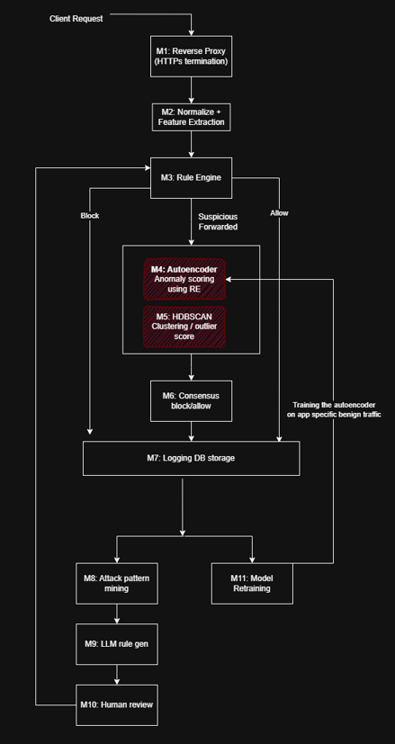

System Limitations / Constraints
LI-1: The WAF prototype is deployment-agnostic, meaning it can be deployed on-prem or in cloud in front of Backend servers.
LI-2: Detection of zero-day attacks relies on patterns learned from historical traffic, so extremely novel attack techniques may not be immediately detected.
LI-3: The AI-generated rules require human validation before deployment, which may introduce delays in automated response.
LI-4: The system focuses on web application layer security (HTTP/HTTPS) and does not provide network-level protections like DDoS mitigation or firewalling for non-web traffic.
LI-5: Threat intelligence integration depends on publicly available sources, which may not always provide complete or up-to-date information.
LI-6: Some complex or encrypted payloads may affect feature extraction accuracy and anomaly detection performance.
LI-7: The dashboard and analytics are limited to operational monitoring and academic evaluation and do not include advanced incident response automation.
LI-8: The system assumes that backend applications are properly configured and secure; it does not prevent attacks that exploit backend misconfigurations outside of HTTP/HTTPS requests.

Data Gathering Approach
The data gathering for the proposed AI-powered WAF involves collecting both technical and organizational information. Historical web traffic logs and publicly available datasets (e.g., CSIC 2010) will be used to train and evaluate AI models. Requirement information, such as custom rules, threat intelligence sources, and dashboard preferences, will be collected through interviews and discussions with potential system users or administrators. Additionally, existing research papers, online resources, and threat intelligence feeds will be reviewed to understand common attack patterns and rule generation strategies.

Project Contribution
The proposed AI-driven Web Application Firewall introduces several technical and conceptual contributions that differentiate it from traditional and commercial WAF solutions:
- AI-Powered Unknown attack Detection: Integrates an autoencoder-based anomaly detection model combined with HDBSCAN clustering to identify previously unseen attacks, providing enhanced security beyond signature-based WAFs.
- Layered Security Architecture: Combines fast rule-based filtering, threat intelligence, and unsupervised AI in a unified system, ensuring both immediate threat mitigation and adaptive protection.
- AI-Enhanced Rule Generation: Automatically mines attack patterns from confirmed malicious traffic to create new WAF rules, enabling continuous self-improvement and reducing manual rule-writing effort.
- Human-in-the-Loop Validation: Balances automation with administrative oversight, allowing safe deployment of AI-generated rules while maintaining operational trust.
- Explainable AI Decisions: Logs all features and reasoning behind allow/block decisions, providing transparency, auditability, and forensic value.
- Traffic Normalization and Feature Extraction: Standardizes requests into structured JSON and extracts behavioral/contextual features, enabling accurate machine learning analysis and efficient processing.
- Dashboard Visualization and Analytics: Provides real-time monitoring of attack trends, rule effectiveness, and endpoint risk scores, enhancing operational visibility and usability for administrators.
- Continuous Learning Loop: Implements a closed-loop system that integrates detection, pattern mining, rule generation, and validation, improving detection accuracy over time.
Contribution Impact:
By combining AI, threat intelligence, rule-based filtering, and explainable decision-making, this project transforms a conventional WAF into an adaptive, self-learning, and transparent security solution. It improves detection of zero-day attacks, reduces reliance on manual rule creation, and enhances operational monitoring, offering a novel and practical approach to web application protection.

Relevance to Course Modules:
- Cybersecurity: Applied knowledge of web security, threat modeling, penetration testing concepts, and zero-day attack detection.
- Software Engineering: Followed SDLC phases, requirement analysis, system design, and modular development for the WAF.
- Database Systems: Implemented MongoDB for storing normalized traffic, AI features, rules, and logs, enabling efficient queries and analytics.
- Artificial Intelligence & Machine Learning: Designed and trained autoencoder-based anomaly detection models and used clustering (HDBSCAN) for latent-space validation.
- Web Technologies: Developed a web-based dashboard for real-time visualization, rule management, and operational monitoring.
- Networking & Cloud Security: Applied reverse proxy architecture, TLS termination, and traffic interception to secure web applications.
- DevSecOps & Automation: Integrated continuous learning loop, automated AI-driven rule generation, and human-in-the-loop validation for adaptive security.

Tools and Technologies for Proposed Project
Tools and Technologies | Version | Rationale
Go (Golang) | 1.21 | Implementing reverse proxy, traffic interception, and WAF core logic.
MongoDB | 6.2 | Storage of normalized traffic, AI features, rules, and logs for query and analysis.
Python | 3.11 | AI/ML model development (autoencoder, clustering, pattern mining).
TensorFlow / Keras | 2.x | Building and training autoencoder for anomaly detection.
HDBSCAN (Python library) | 0.8 | Latent-space clustering to reduce false positives and detect unknown attacks.
FP-Growth (MLxtend / Python) | Latest | Pattern mining for AI-enhanced rule generation.
Docker | 24.x | Containerization for reproducible environment and service deployment.
Nginx | 1.26 | Optional reverse proxy and load balancing during testing.
VS Code | 1.91 | Integrated development environment for code editing and debugging.
Git / GitHub | Latest | Version control and code repository management.
HTML / CSS / JavaScript | Latest | Dashboard front-end development for visualization and rule management.
Plotly / Chart.js | Latest | Visualization of traffic trends, anomalies, and analytics in dashboard.
RESTful APIs | N/A | Communication between dashboard, backend, and AI modules.
Postman | Latest | Testing and debugging APIs and request flows.

Project Stakeholders and Roles

Table 3 Project Stakeholders for Proposed Project
Project Sponsor | COMSATS University Islamabad, Islamabad Campus
Stakeholder | Student 1: Syed Shaheer Khalid  Student 2: Javaria Maqbool  Supervisor: Ms. Farhana Jabeen  Final Year Project Committee: Evaluation of Project

Module based Work Division
Table 4 Team Member Work Division for Proposed Project
Student Name | Student Registration Number | Responsibility/ Module / Feature
Syed Shaheer Khalid | SP23-BCT-048 | Module 7.1 (FE 1-3) Reverse Proxy Traffic interception  Module 7.2 (FE 1-3) Traffic Normalization & Feature extraction  Module 7.3 (FE 1-3) Rule-based filtering engine  Module 7.4 (FE 1-3) AI Anomaly detection (Encoder)  Module 7.5 (FE 1-3) Latent-space clustering (HDBSCAN)  Module 7.6 (FE 1-3) Multi-signal Consensus Engine
Javaria Maqbool | SP23-BCT-023 | Module 7.7 (FE 1-3) Logging & Explainability Storage  Module 7.8 (FE 1-3) Attack pattern mining engine  Module 7.9 (FE 1-3) LLM-Assisted Rule Generation  Module 7.10 (FE 1-3) Human-in-loop rule validation dashboard  Module 7.11 (FE 1-3) Continuous Learning & Fine-tuning loop

WBS and Gantt Chart
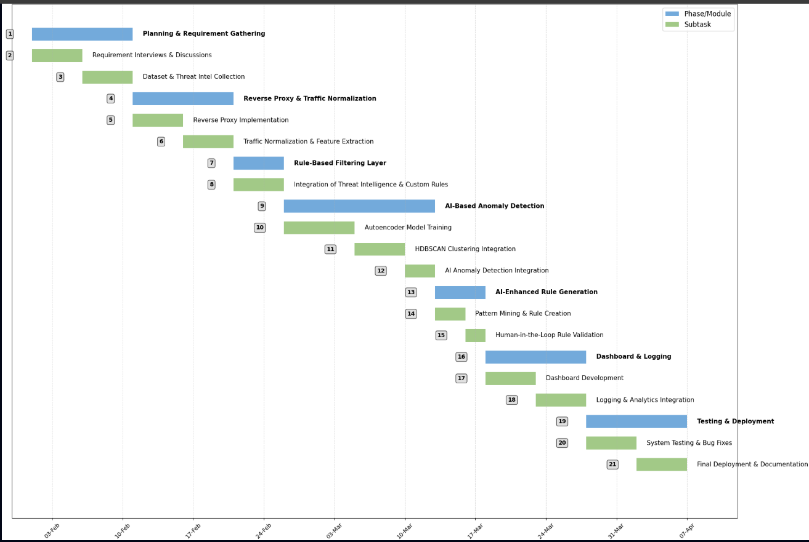

Mockups
Dashboard:
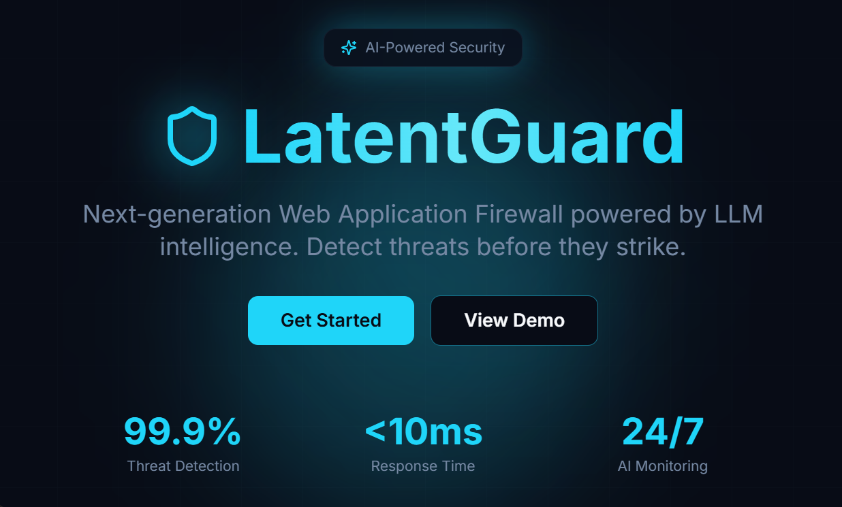
Live Logs:

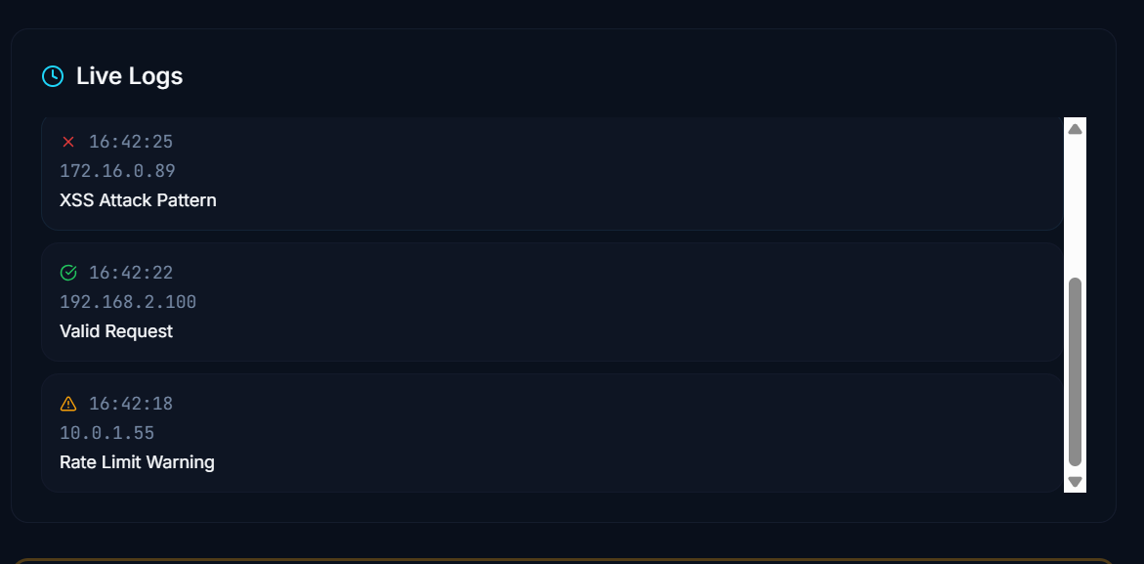
Ai-generated rules:
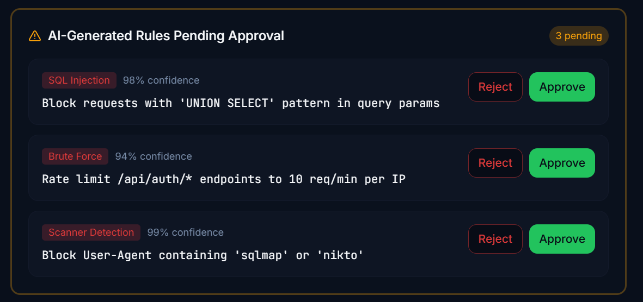

References
• https://theaspd.com/index.php/ijes/article/view/11769
• https://ai.updf.com/paper-detail/adaptive-web-application-firewall-for-multi-threat-detection-maheshwari-nayak-a10eb22e6476527d219539c7326c9a4de0cad182
• https://pubmed.ncbi.nlm.nih.gov/40989350/
• https://arxiv.org/abs/2512.23610
• https://irjiet.com/common_src/article_file/1732866575_b16a582e04_8_irjiet.pdf
• https://ijsrcse.isroset.org/index.php/j/article/view/526
- 2511.12643
- Learning from Limited Heterogeneous Training Data: Meta-Learning for Unsupervised Zero-Day Web Attack Detection across Web Domains

Plagiarism Report

